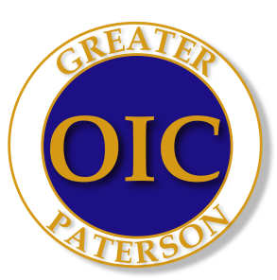

Name: ________________________________ Date: _____________________

Test #2

Please circle correct letter in front of the statements.

- The law says that all vehicles must have ____.
- a CB radio
- a muffler and exhaust system in good shape
- a jack and a spare tire
- a heating system

- To get a driver’s license, you must prove that you ____.
- are a citizen of the United States
- have a high school diploma
- are old enough to drive
- do not wear eyeglasses

- When you come to a school bus that has its red lights flashing, you must ____.
- slow down to 20 mph
- pass the bus with caution
- swing wide and give the bus, the right of way
- stop until the bus has turned off its lights

- Which of the following hand signals is for a right turn?
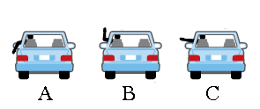
- If you approach a red traffic light and a police officer signals you to drive through the intersection, you should ____.
- drive straight through without stopping
- stop, because the light is red
- slow down and ask the officer, if it’s safe to drive through
- pull over to the right hand curb

- By driving a car on New Jersey State roadways, you agree to take a test for drunk driving, if a police officer asks you too. This law is called ____.
- Organ Donor Program
- Implied Consent
- the two second rule
- the point system
- When a vehicle behind you wants to pass your car, you should ____.
- speed up
- slow down
- drive at the same speed
- move sharply to your right

- On a freeway, if you drive pass the exit where you wanted to get off, you should ____.
- stop immediately and back up to the exit
- wait until other traffic has passed and then back up to the exit
- turn around and drive back to the exit
- drive to the next exit and get off there

Continue to next page,

- Parking may be permitted ____.

- across a intersection or crosswalk
- in a tunnel or on a bridge
- on a one way street
- within (3) three feet of a fire hydrant

- A double solid line in the middle of a roadway means ____.
- cars on the right can pass
- cars on the left can pass
- cars on both sides can pass
- no cars can pass

- An emergency vehicle with its lights flashing has the right of way ____.
- only at intersections
- only in the city
- on freeways
- at all times

- Night driving is ____.
- more dangerous than daytime driving
- less dangerous than daytime driving
- the same as daytime driving
- only dangerous in bad weather

- License Plates show ____.
- that you have a drivers license
- that you have car insurance
- that your has been inspected
- that your car is registered

- A safe distance between you and the vehicle ahead of you on the highway ____.
- 10 feet
- (1) one car length for every 10 mph you are driving
- (1/2) one-half car length for every 10 mph you are driving
- Close enough to read the bumper sticker on the car ahead

- When making a turn on gravel, sand or other loose materials, a motorcycle should ____.
- drive very slowly around the turn
- speed up and drive as quickly as possible through the loose material
- make the turn very sharply
- skid through the material

- If, your car hits and damages an unattended vehicle, you should ____.
- drive away as quickly as possible
- wait until the driver of the unattended vehicle arrives
- leave a note, with your name and address on the unattended vehicle
- find a witness, who will say “that the accident wasn’t your fault”

- When you come close to an intersection with a “flashing” yellow (amber) light, you should ____.
- drive through at a normal speed
- slow down and drive through carefully
- stop and wait until the light stops flashing
- speed up and drive through before another car comes

- If your right wheel goes off the pavement, you should ____.
- turn the wheel sharply back onto the road
- stop and wait for a tow truck
- push hard on your brakes
- slow down and steer straight a head
- Collision Insurance pays for ____.
- damage to your car, if you are in a collision
- damage to the other vehicle, if they are in a collision with you
- death or personal injury that happens in a collision
- none of the above

- With a learners permit, you can ____.
- only drive at night
- only drive in the city
- only with a licensed driver
- only with your parent

Questions 21 thru 25 refer to signs on your right of page.
- Road sign (A) means ___.
- Do Not Enter
- Slow down & Stop, give other traffic the right-of-way
- Cattle Crossing
- One-Way Street

- Road sign (B) means ___.
- Divided Highway
- Keep Left
- Traffic signal ahead
- Falling Rocks

- Road sign (C) means ___.
- Steep hill
- Narrow Bridge
- Do Not Pass
- Slippery When Wet

- Road sign (D) means ___.
- Lane Reduction
- Merge Left
- Use left hand lane only in emergency
- Other traffic will be coming from the left

- Road sign (E) means ___.
- You are driving into a School Zone
- You are leaving a School Zone
- Pedestrian Crossing
- You are approaching an intersection

City and Highway Road Signs

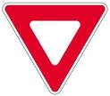

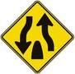

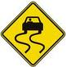

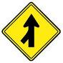

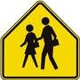
End of Test #1

“The two hardest things to handle in life are failure and success”
Dr. Joyce Brothers

