Name: ____________________________________________ Date: ____________________________

***Fill in circle with the correct answer:***

**1.**

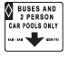

**a.** Yield

**b.** Cross road

**c.** Bus/car pool lane

**d.** Side road

**2.**

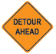

**a.** Interstate

**b.** Detour

**c.** Keep right

**d.** Flagman

**3.**

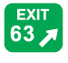

**a.** Exit marker

**b.** Hill

**c.** State route marker

**d.** No trucks

**4.**

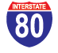

**a.** State route marker

**b.** Multiple turning lanes

**c.** Interstate

**d.** U.S. route marker

**5.**

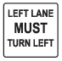

**a.** Advisory ramp speed

**b.** Merge

**c.** Left turn only

**d.** Road narrows

**6.**

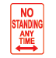

**a.** No standing any time

**b.** Wrong way

**c.** Yield ahead

**d.** No passing

***Continue on to next page ***

**7.**

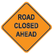

**a.** Winding road

**b.** No standing any time

**c.** No turns

**d.** Road closed

**8.**



**a.** Interstate

**b.** Sharp turn

**c.** U.S. route marker

**d.** State route marker

**9.**



**a.** Road closed

**b.** Bus/car pool lane

**c.** Two-lane traffic

**d.** Multiple turning lanes

**10.**



**a.** U.S. route marker

**b.** Workers

**c.** State route marker

**d.** Merge

**11.**

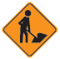

**a.** Flagman

**b.** Cattle crossing

**c.** Road closed

**d.** Workers

**12.**

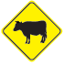

**a.** Cross road

**b.** Cattle crossing

**c.** Railroad

**d.** Yield ahead

***Continue on to next page ***

**13.**

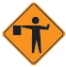

**a.** Wrong way

**b.** Road closed

**c.** Flagman ahead

**d.** Right turn only

**14.**

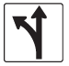

**a.** Signal ahead

**b.** Yield

**c.** Detour

**d.** Left or straight only

**15.**

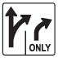

**a.** Left or straight only

**b.** Multiple turning lanes

**c.** Left turn only

**d.** No U-turns

**16.**



**a.** Do not pass

**b.** Hill

**c.** No trucks

**d.** Slippery when wet

**17.**

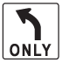

**a.** No U-turns

**b.** Left turn only

**c.** Winding road

**d.** Sharp turn

**18.**

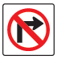

**a.** No right turn

**b.** Interstate

**c.** Winding road

**d.** Advisory ramp speed

***Continue on to next page ***

**19.**

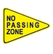

**a.** Side road

**b.** Keep right

**c.** Hill

**d.** No passing

**20.**

http://www.state.nj.us/mvc/manuals/images/signs/20signs.gif

**a.** Merge

**b.** Rest area

**c.** Road narrows

**d.** School

**21.**

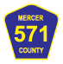

**a.** U.S. route marker

**b.** County road marker

**c.** Winding road

**d.** Interstate

**22.**

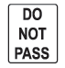

**a.** Do not pass

**b.** Right turn

**c.** Left or straight only

**d.** Sharp turn

**23.**

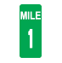

**a.** Road closed

**b.** Advisory ramp speed

**c.** Bus/car pool lane

**d.** Mile marker

**24.**

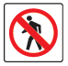

**a.** Wrong way

**b.** No standing any time

**c.** No pedestrians

**d.** No turns

***Continue on to next page ***

**25.**



**a.** Handicapped

**b.** Hospital

**c.** Divided highway

**d.** Detour

**26.**

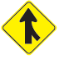

**a.** Merge

**b.** Stop

**c.** Multiple turning lanes

**d.** Left turn only

**27.**

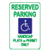

**a.** Reserved parking

**b.** No parking

**c.** Slippery when wet

**d.** Workers

**28.**

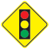

**a.** Yield

**b.** State route marker

**c.** Signal ahead

**d.** Do not pass

**29.**

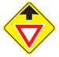

**a.** No U-turns

**b.** No parking

**c.** Yield ahead

**d.** Bus/car pool lane

**30.**

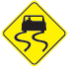

**a.** Slippery when wet

**b.** Road closed

**c.** Cross road

**d.** Side road

***Continue on to next page ***

**31.**



**a.** Cross road

**b.** Stop here on red

**c.** Wrong way

**d.** Railroad

**32.**

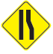

**a.** Advisory ramp speed

**b.** Lane reduction ahead

**c.** Multiple turning lanes

**d.** Sharp turn

**33.**

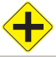

**a.** Flagman

**b.** Railroad

**c.** Cross road

**d.** Stop here on red

**34.**

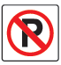

**a.** No trucks

**b.** No turns

**c.** No passing

**d.** No parking

**35.**

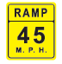

**a.** Mile marker

**b.** Rest area

**c.** Advisory ramp speed

**d.** Cattle crossing

**36.**

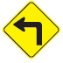

**a.** Winding road

**b.** Sharp turn ahead

**c.** No right turn

**d.** Yield ahead

***Continue on to next page ***

**37.**

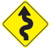

**a.** Wrong way

**b.** No standing any time

**c.** Winding road

**d.** No right turn

**38.**

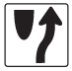

**a.** Left turn only

**b.** No turns

**c.** Keep right

**d.** Exit marker

**39..**

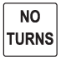

**a.** Signal ahead

**b.** No left turn

**c.** No right turn

**d.** No turns

**40.**

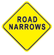

**a.** Road narrows

**b.** One way

**c.** Divided highway

**d.** Keep right

**41.**

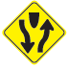

**a.** Do not pass

**b.** Divided highway

**c.** Do not enter

**d.** No U-turns

**42.**

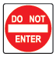

**a.** Advisory ramp speed

**b.** No trucks

**c.** Workers

**d.** Do not enter

***Continue on to next page ***

**43.**



**a.** Hospital

**b.** Handicapped

**c.** School

**d.** Yield ahead

**44.**

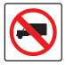

**a.** No trucks

**b.** Keep right

**c.** Hill

**d.** Yield

**45.**

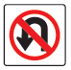

**a.** Flagman

**b.** No turns

**c.** No U-turn

**d.** Left or straight only

**46.**

http://www.state.nj.us/mvc/manuals/images/signs/46signs.gif

**a.** No right turn

**b.** Multiple turning lanes

**c.** No left turn

**d.** One way

**47.**

http://www.state.nj.us/mvc/manuals/images/signs/47signs.gif

**a.** Cross road

**b.** Winding road

**c.** Flagman

**d.** Road closed

**48.**



**a.** Stop

**b.** Merge

**c.** Yield

**d.** Workers

***Continue on to next page ***

**49.**

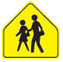

**a.** Hospital

**b.** Pedestrian crossing

**c.** School

**d.** No parking

**50.**

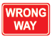

**a.** U.S. route marker

**b.** Wrong way

**c.** No right turn

**d.** Left turn

**51.**

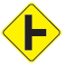

**a.** Side road

**b.** Cross road

**c.** Road closed

**d.** No passing

**52.**

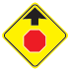

**a.** Road narrows

**b.** Stop ahead

**c.** Yield ahead

**d.** Sharp turn

**53.**

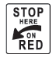

**a.** Stop here on red

**b.** One way

**c.** Interstate

**d.** Merge v

**54.**



**a.** Side road

**b.** Yield

**c.** Merge

**d.** Stop

***End of Test***