Name: ________________________________ Date: _____________________

Final Prep Examination

Please circle correct letter in front of the statements.
- A flashing yellow/amber light means:
- Stop
- Slow down
- Stop and proceed with caution
- Speed up

- Which of the following colors is for a traffic warning sign?
- white
- blue
- red
- orange

- At what rate of speed do airbags deploy in a collision?
- 75 mph
- 125 mph
- 200 mph
- 250 mph

- A twelve –ounce can of beer has as much alcohol in it as:
- 1 ½ oz. glass of 86 proof whiskey
- Bottle of rum
- Martinis
- Pint of Brandy

- What is a Habitual Offender?
- Any person whose license has been suspended once
- Any person whose license has been suspended 2 times in 2 years
- Any person whose license has been suspended 3 times in 3 years
- Any person whose license has been suspended 1 time in 2 years

- As you drive, you must turn your headlights on when:
- You turn on your wipers on
- ½ half hour after sunset
- ½ half hour before sunset
- ½ half hour after sunset and ½ half hour before sunrise
- A special permit may be issued at age 16, when:
- the applicant is enrolled in a “Behind the Wheel Driver Ed. Course”
- the applicant is enrolled in a “Commercial Driver Ed. Course”
- Purchased by an approved Driving Instructor
- All of the above

- The three-second rule can be used at any speed to help you:
- drive within the speed limit
- keep a safe following distance
- time traffic lights at intersections
- bring your vehicle out of a skid

- If , a person gets drunk in your home and has a motor vehicle collision after leaving your home you could:
- be charge with a crime
- not be held responsible
- be involve in a lawsuit
- None of the above
Continue Next Page

- The Implied Consent Law is:
- Permission for someone to drive your vehicle
- All passengers must wear seatbelts
- You agree to take a “Breathe Test”, when under arrest and suspected of drinking and driving
- All of the above

- If , a student driver commits a traffic offense, responsibility will lie with:
- only the student
- only the instructor
- neither student, nor instructor
- both student and instructor

- A person may operate a Moped with:
- a valid basic license
- a valid motorcycle license
- a valid moped license
- All of the above

- What is the proper parking distance, when parallel parking?
- 35 feet
- 25 feet
- 22 feet
- 20 feet

- A triangular sign with an orange center and red border means:
- school bus
- yield
- stop
- slow moving vehicle
- The meaning of a hand-signal, when a drivers hand and arm are straight out is:
- a U-turn
- a right turn
- a left turn
- a slowing down or stop

- The shape of a “STOP “sign is:
- octagon
- diamond
- triangle
- circle

- Driving, While under the influence of intoxicating beverages (DUI/DWI) means:
- A driver shows obvious signs of being drunk
- Your senses or judgment are impaired by alcohol
- Drinking while in process of driving a vehicle
- Driving even if the driver has had one drink

- What document do you needed to take your “Road Test”:
- valid Vehicle Registration
- valid Examination Permit
- valid Insurance Card
- All of the above

- The best way to take a curve is to:
- lean in the direction of the curve
- speed up, while in the curve
- slow down before entering the curve
- slow down after entering the curve

- If your wheels go off the pavement and you want to return to the road from a dirt shoulder, you should:
- Slow down, and turn your wheels to climb back on to the pavement edge
- Drive along the shoulder until you are going as fast as the traffic on the road
- Drive along the shoulder until you get an acceleration lane
- Move slowly onto the road and wave traffic around you
Continue Next Page
- You are under the influence of alcohol, if your BAC level has reached:
- 0.15%
- 0.8%
- 0.05%
- All of the above

- Road surfaces are slipperiest:
- during very hot and humid weather
- after a very heavy rainfall
- during very cold weather
- during the first few minutes of rainfall

- If, a student fails the “Road Test” for the first time, how long does he/she wait before taking it again?
- 5 days
- 7 days
- At least 14 days
- 30 days

- The best way to reduce your chance of having an alcohol related accident is to:
- reduce your drinking
- have a meal before drinking
- know your own limits
- don’t drink and drive

- If, you come to a (4) four-way Stop at the same time as another driver, you must :
- Yield to the driver on the left
- Yield to the driver on the right
- Yield to oncoming cars
- Yield to the passing cars

- Whether your blood alcohol content rises above legal limits depends on:
- amount you drink
- your weight
- how fast drinks were consumed
- All of the above
- After you drive through a deep puddle of water, you should:
- Pump your brakes to test them
- Race your engine to dry it out
- Apply brakes hard to test them
- Speed up to dry your tires

- If, two(2) cars begin to enter an uncontrolled intersection at the same time:
- The driver on the right must” Yield” to the driver on the left
- The driver on the left must” Yield” to the driver on the right
- The driver entering the intersection must “Yield”
- The driver going straight through goes first

- What is the “Speed limit” in a business district in New Jersey?
- 35 mph
- 20 mph
- 25 mph
- 30 mph

- Persons under “21 years” of age (the legal drinking age) are considered under the influence of (DUI), when their (BAC) level is:
- 0.01
- 0.05
- 0.08
- All of the above

- The proper parking distance from a curb is:
- 12 inches
- 1 foot
- 6 inches
- 2 feet

Continue Next Page
- You must “Yield” to Emergency vehicles:
- Never
- When you see red or blue flashing lights or hear a siren
- Only, when other vehicles yield
- All of the above

- New Jersey law allows up to (3) three points to be subtracted from your driving record, if you have no traffic(moving) violations:
- For (1) one year from the date of the last violation
- For (6) six months
- For (18) eighteen months
- For (2) two years

- In city driving, a good habit is to:
- Use the (2) two- second rule
- Look (12) twelve –seconds ahead
- Reduce speed and use the horn
- Practice good judgment

- If, your vehicle tire suddenly has a blowout, you should:
- Speed up
- Continue driving normally
- Slow down gradually
- Break instantly

- If, you are involved in a motor vehicle accident resulting in injuries, “while you’re driving privileges are suspended” you are subject to:
- a fine set by the judge
- further suspension of your driving privileges
- fine, suspension of your driving privileges and mandatory (45) forty-five day s jail sentence
- All of the above

- When driving a motor vehicle you are required to have a drivers license and your:
- Title to the vehicle and Registration
- Registration and Insurance Card
- Insurance Identification card and certificate of ownership
- Title of the vehicle and insurance card

- To obtain a New Jersey license or non-driver ID card , you must present these identifiers:
- Proof of age
- Proof of identity
- Proof of citizenship
- Proof of age, identity and that your presence in the country is authorized under federal law

- When a school bus has stopped directly in front of a school to pick up or let off children, you may pass from either direction at a speed of no more than:
- 10 MPH
- 15 MPH
- 20 MPH
- 25 MPH

- When should you use your high beam lights?
- City driving
- Driving foggy weather
- During heavy rainfall
- Open country diving
- You may drive on public or private property to avoid a traffic sign or signal:
- Only the driver stops the vehicle before crossing the sidewalk
- Only with permission of the property owner
- Anytime
- When directed to do so by a police officer
Continue Next Page

- The meaning of a hand-signal, when a drivers hand and arm is upward is:
- U-turn
- Right turn
- Left turn
- Slow/Stop

- The order of colors on a traffic light hung from top to bottom:
- red, green and yellow/amber
- yellow/amber, green and red
- red, yellow/amber and green
- green, yellow/amber and red

- What lights should you use during fog?
- Low beams
- High beams
- No lights
- Hazards lights

- The inspection sticker on a new vehicle is good for at least:
- 18 months
- 48 months
- 36 months
- 24 months

- Hydroplaning is a driving condition, wherein tires lose traction on a wet road and float on a layer of water or slush, when this happen, you should:
- push the brake pedal down hard
- increase speed
- slow down
- change lanes

- When parking downhill on a street with a curb on the right, your car wheels should be:
- Turned towards the curb
- Turned away from the curb
- Turned straight ahead
- Turned to the left
- A single solid white line across, a road at an intersection means?
- Stop behind the line for traffic sign or light
- Bus stop
- No Parking zone
- No Passing

- If, your permit is stolen or lost, you should:
- Contact your local police department to report it
- Call your driving school, if you are (16) sixteen and need a duplicate
- Wait to drive, until a replacement is processed
- All of the above

- How much time do you have to notify MVC (Motor Vehicle Commission) of a name change?
- One week
- Two weeks
- 1 month
- You don’t have to notify them

- A person who holds a Probationary (Provisional) driver license is subject to:
- An advisory notice upon being convicted of their first moving violation
- Mandatory attendance at a driver education program in lieu of suspension for a second violation resulting in a four or more points
- Any violation after attending school will result in suspension
- All of the above

Continue Next Page
- To avoid highway hypnosis when driving on an expressway it is a good practice to:
- rest your eyes by slowly blinking them time to time
- Avoid looking at any one thing for more than a few seconds
- Look straight ahead or to the side
- Spending as much time looking at your mirrors as you do looking in front of you

- If, you are arrested for “Drunk Driving” DWI in New Jersey, your chances of being convicted are:
- 80%
- 50%
- 90%
- 75%

- Before turning, you must signal at least:
- 500 feet
- 1 block
- 100 yards
- 100 feet in advance

- Points are issued for what?
- Not having proper identification
- Moving violations
- Not wearing seatbelts
- Brake lights that don’t work

- What are some telltale signs of a drunk driver?
- Weaving between lanes
- Driving slower than the normal traffic flow
- Quick and sudden stops
- All of the above

- Does New Jersey issue a work license to people, who have lost their driving privileges?
- Depends on the offense
- Sometimes
- No
- Always

- Where are the blind spots in your rearview mirror?
- Only the left side
- On the left and right sides and behind your rear window posts
- Only on the right side
- Blind spots don’t really exist

- When it is legal to make a right turn on red, you must:
- Turn before the light turns green
- Stop and wait until the light turns green
- Signal for a right-turn and make turn without looking
- Make a full stop and check traffic

- When making a left turn from a two-way street, you should get into the:
- right lane or the lane farthest from the center lane
- left lane nearest to the left curb
- lane nearest to the center of the roadway
- right lane or the nearest lane to the right curb

- When a school bus is stopped and has its red lights flashing, you should:
- Yield
- Stop
- Slow down
- Overtake it from the left

Continue Next Page
- If, you have had a license for over (2) two years, you will get a notice of suspension. If, you have how many points on your license?

- 6 points
- 12 points
- 9 points
- 3 points

- Studies show that the greatest number of people arrest for DUI/DWI (drunk driving) had been drinking, what kind of alcoholic beverage?

- Whiskey
- Wine
- Cognac
- Beer

- Drugs that may affect basic driving skills are:

- Cold pills
- Tranquilizers
- Some prescription drugs
- All of the above

- The best way to talk to other drivers is to:

- Roll down the window and talk
- Use your horn
- Flash your high beams
- Hit them with your car

- How close may you park to a Stop sign?

- 15 feet
- 10 feet
- 50 feet
- 25 feet.

- How close may you park to a Crosswalk?

- 50 feet
- 100 feet
- 25 feet
- 10 feet

- What is the penalty for driving with a suspended license?

- A fine of $500 & up to (6) six months additional suspension (second offense)
- A fine of $600 & up to (5) five months additional suspension
- A fine of $500 & up to (6) six months additional suspension (first offense)
- A fine of $600 with a pardoning gift

- What are the penalties for driving without insurance?
- Suspension of Driver License
- A fine
- Suspension of Registration
- All of the above

- What test must you pass to get your examination permit validated?
- Road test & eyesight
- CDL & eyesight
- Vision & Knowledge
- All of the above

- If, your vehicle goes into a skid you should:
- Apply brakes & turn the wheels away from skid
- Release gas pedal, turn wheels into the direction of skid, do not apply brakes
- Speed up and hit the brakes
- Grab steer wheel and call for help

- Liquor, beer and wine:
- Speeds up your reaction time & makes you a better driver
- Slows down your reaction time & makes you a worst driver
- Do not influence your driving at all
- Make you drive much more carefully

- The law says that all vehicles must have:
- CB radio
- Jack and Spare tire
- Muffler & Exhaust system
- Heating system
Continue Next Page

- Which of the following are the proper steering grips?
- 2 O’clock & 6 O’clock
- 9 O’clock & 3 O’clock
- 12 O’clock & 5 O’clock
- 10 O’clock & 12 O’clock

- When a vehicle behind you wants to pass your car, you should:
- Speed up
- Drive at the same speed
- Slow down
- Move sharply to the right

- Night driving is:
- more dangerous than daytime driving
- less dangerous than daytime driving
- only dangerous in bad weather
- the same as daytime driving

- On low beams, car headlight must shine at least:
- 20 feet
- 100 feet
- 300 feet
- ½ half a mile

- What is the correct way to cross railroad tracks on a motorcycle?
- On a slant
- At a high speed
- At a right angle
- At the edge of the road

- What is the proper following distance, when traveling at 50 MPH:
- 3 car lengths
- 2 car lengths
- 5 car lengths
- 4 ½ car lengths

- Cars must have ___ set(s) of brakes?
- 3
- 1
- 2
- 4

- New Jersey Child Restraint Law requires that:
- passengers under (8) eight years of age must be secured in child restraint system
- booster seats must be in the rear of the vehicle, if there is no rear seat, it may be used in the front seat
- restraint systems must meet all Motor Vehicle Federal Safety Standards
- All of the above

- Child Restraint Law, states that passengers under (8) eight years of age. Who weigh more than 80 lbs., must wear a seatbelt, whether in the front or rear seat.
(TRUE or FALSE)

- You must drive on an icy or snowy covered roadway, which of the following should you do?
- Use a smaller following distance
- Apply the brakes during turns
- Slow down gradually and stop, if conditions become dangerous
- All of the above

- An acceleration lane is:
- a extra lane to park in for emergencies
- a extra lane to exit highway
- a extra lane used to slow down
- a extra lane used to speed up

- Straight Trucks, Tractor-Trailers & Buses are allowed to travel on state and county road, when:
- making deliveries, pick-ups or commercial business
- while off duty
- normal everyday driving
- anytime

- What is a safe distant for following trucks or buses?
- 10-20 feet
- 100 feet
- 120 feet
- 200 feet or more
Continue Next Page
- When stopping at a traffic light or “Stop” sign behind a truck that’s facing up-hill, you should leave ample space, so that the truck doesn’t roll back into you.
(TRUE or FALSE)

- You are driving and you see a bicyclist on the roadway, what do you do?

- Run him/her over with your vehicle
- Speed up
- Use your horn
- Yield to the bicyclist
Questions 89 thru 103use signs to answer
- Which sign means that a “Railroad Crossing” is ahead?
- A
- B
- C
- D
- E

- Which sign means there is a “STOP” sign ahead?
- A
- B
- C
- D
- E

- Which sign tells that there is a Sharp turn ahead?
- A
- B
- C
- D
- E

- Which sign means “No Right Turns”?
- A
- B
- C
- D
- E

- Which sign tells you, that “No Parking” is allowed?
- A
- B
- C
- D
- E

- 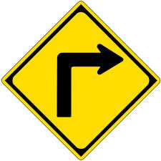

- 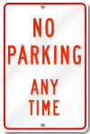
- 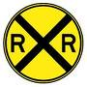

- 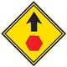
- 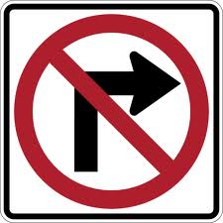
_______________________________________________________________

- Road sign A means, what?
- Do Not Enter
- Cattle Crossing
- One way
- Yield

Continue Next Page
- Road sign B means, what?
- Keep to the Left
- Divided Highway
- Divided Highway ends
- Traffic Signal ahead

- Road sign C means, what?
- Steep Hill
- Narrow Bridge
- No Passing
- Slippery When Wet

- Road sign D means, what?
- Lane Reduction
- Divided Highway ends
- Merge to the right
- Extra Lane

- Road sign E means, what?
- You are leaving a “School Zone”
- You are approaching an “Intersection”
- Pedestrian Crossing
- You are driving into a “School Zone”

- 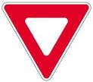

- 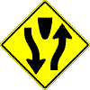

- 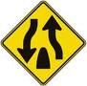

- 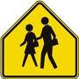

_______________________________________________________________

- What sign tells you there is a “Steep Hill” ahead?
- A
- B
- C
- D
- E

- What sign tells you there is “Two Way Traffic”
- A
- B
- C
- D
- E

- What sign tells you there is a “Winding Road” ahead?
- A
- B
- C
- D
- E

Continue Next Page

- What sign tells you that traffic will “Merge” from the left?
- A
- B
- C
- D
- E

- What sign tells you that this is a “One Way”
- A
- B
- C
- D
- E

- 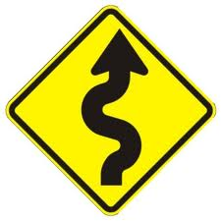
- 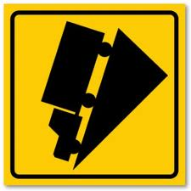
- 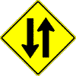
- 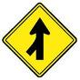

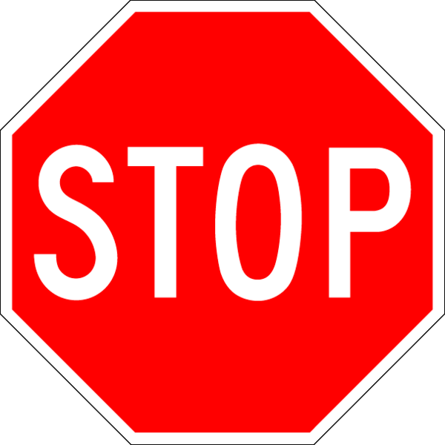

End of Test

“Defeat is a state of mind; no one is ever defeated until defeat has been accepted as a reality.”
Bruce Lee

